King Abdulaziz University
Faculty of Meteorology, Environment and Arid Land Agriculture
Department of Hydrology and Water Resources Management
1st Term 1430/1431 15/11/1430

HWR 301
Fluid Mechanics
Exercise 2

Assumes the following: Gravitational acceleration, g = 9.81 m/s², Mass density of water, ρ = 1000 kg/m³ and Mercury specific gravity is 13.6

- A U tube with both ends open to the atmosphere contains mercury in the lower part of the tube. If water is filled into one leg of the U-tube until the water column is 1 m above the mercury-water interface, what is the elevation difference between the mercury surfaces in the two legs?

- If oil (sp. gr. 0.79) if filled into the other leg of the above manometer to height of 60 cm, what is the elevation difference between the mercury surfaces?

- A manometer is mounted on a city water supply main pipe to monitor the water pressure in the pipe, as shown in the figure. Determine the water pressure?
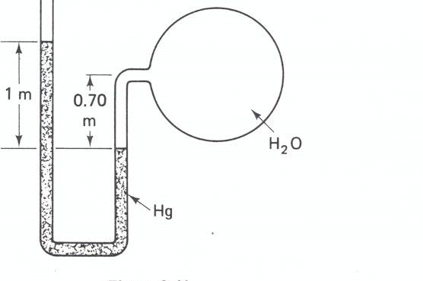

- Mercury is used as the manometer liquid to measure the water pressure in pipe A. Determine the pressure when the manometer readings are as shown in the figure?

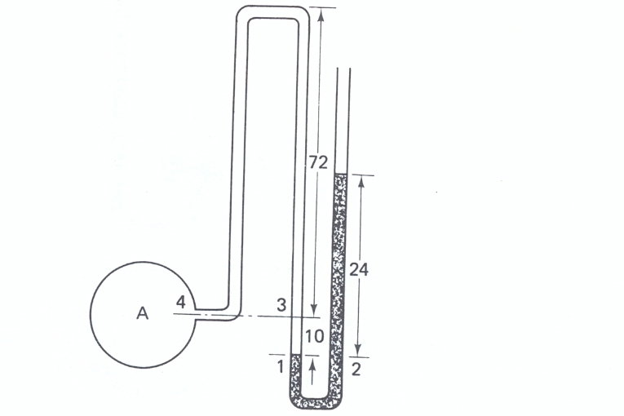

- In the given figure fluids A and B have specific gravities of 0.75 and 1.0, respectively. If mercury is used as the manometer liquid, determine the pressure difference between A and B?

