King Abdulaziz University
Faculty of Meteorology, Environment and Arid Land Agriculture
Department of Hydrology and Water Resources Management
May 17, 2009 2^{ed} Term 29/30

HWR 443
Design of Urban Water Networks

Assignment No. 5

Solve the following problems using the WaterCAD computer program

- A subdivision of 36 homes is being constructed in the new area of the Jeddah. Each home will require 1,8 l/s during peak periods. All junction nodes are 194 m in elevation. All pipes are ductile iron (C = 130). The current lot and network is shown below. Currently, a model of the entire water system does not exist. However, hydrant tests were conducted using hydrants located on two water mains, one on Jeddah's Highway and the other on Tahlya Street. The following data were obtained:
Jeddah's Highway Hydrant Test:
Static Pressure 311.3 KPa
Residual Pressure 97.5 KPa at 35 l/s.
Elevation of Pressure Gauge 190.o m.
Tahlya Street Gauge Test:
Static Pressure 417.7 KPa
Residual Pressure 322.3 KPa at 42 l/s.
Elevation of Pressure Gauge 191.5 m.
The subdivision will be connected to the existing system at these nodes (J-8 and J-9). (Hint: On the Help drop-down menu, select How do I? Click Appendix A, and then Modelling Tips. Select connection to an Existing Water Main).

  - What is the demands at each of the junction nodes? What is the total demand?
  - Which connection to the existing main is supplying more water to the subdivision? Why?
  - Are the proposed pipe sizes adequate to maintain velocities between 0.2 m/s and 2.44 m/s, and the pressures of at least 150 KPa?
  - Which is better modelling the system in this fashion or modelling the entire system including the new area ?
  - Would the subdivision have enough water if only one connection were used? If so, which one?

Tahlya Street

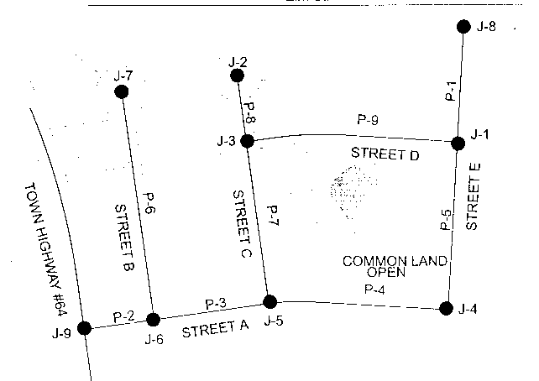

Pipe | Diam. (mm) | Length (m)
P -1 | 150 | 60
P -2 | 150 | 61
P -4 | 125 | 110.5
P -4 | 150 | 164
P -5 | 150 | 152.5
P -6 | 100 | 240
P -7 | 150 | 148
P -8 | 100 | 61
P -9 | 150 | 180
Junctions | No. of homes
J – 1 | 5
J – 2 | 4
J – 3 | 5
J – 4 | 5
J – 5 | 3
J – 6 | 6
J – 7 | 4

- A distribution system is needed to supply water to a residential area for normal usage and emergency use (fire fighting). The proposed system layout is shown in the next page. The source of water is a well. The water is treated and stored in a reservoir which is maintained at elevation of 220 ft. The water is then pumped to the system. An elevated tank is also needed to keep the system running with adequate pressure. The bottom of the tank is at elevation of 386 ft and it is 20 ft height. The tank starts at elevation 385 ft. The pump defining points are: 0 gpm at 220 ft of head, 350 gpm at 200 ft of head and 700 gpm at 140 ft of head. The pump elevation is at the same elevation as junction J-1. The system is to be analyzed under several demand conditions with minimum and maximum pressure constraints. During normal conditions, the junction pressures should be between 35 and 80 psi. Under fire flow conditions, the minimum pressure is at least 20 psi. The pipes ( C = 130) and junctions data are shown below.
  - Fill in the given table to show the system performance under the given demands?
  - What is the pump discharge under average day run?
  - If the pump has a best efficiency point at 350 gpm, what can you say about the pump performance on an average day?
  - How would you judge the system performance for the fire flow cases given? If it does not work, what is the necessary modification to improve the system?

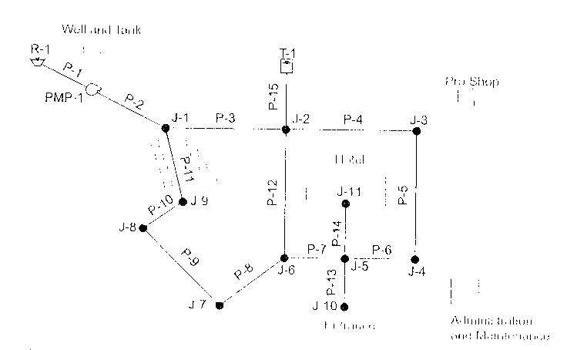

Pipe Information
Pipe | Diam. (in) | Length (ft)
P – 9 | 6 | 400
P – 10 | 6 | 200
P – 11 | 6 | 500
P – 12 | 8 | 400
P – 13 | 6 | 400
P – 14 | 6 | 300
P – 15 | 10 | 2000
Pipe | Diam. (in) | Length (ft)
P -1 | 8 | 20
P -2 | 8 | 300
P -4 | 8 | 600
P -4 | 6 | 600
P -5 | 6 | 500
P – 6 | 6 | 300
P – 7 | 8 | 300
P – 8 | 6 | 500
In order to help evaluating the system performance, it is better to use colour coding range to check the system easily. The following range can be used.

Colour coding range

Max. velocity (ft/s) | Colour
0.5 | magenta
2.5 | blue
5 | green
8 | Yellow
20 | red

Junction Information

Junction | Elevation (ft) | Average Day (gpm) | Peak Hour (gpm) | Minimum Hour (gpm) | Fire with sprinkler (gpm) | Fire without sprinkler (gpm)
J - 1 | 250 | 0 | 0 | 0 | 0 | 0
J - 2 | 260 | 0 | 0 | 0 | 0 | 0
J - 3 | 262 | 30 | 60 | 2 | 500 | 850
J - 4 | 262 | 25 | 50 | 2 | 500 | 850
J – 5 | 270 | 0 | 0 | 0 | 0 | 850
J – 6 | 280 | 0 | 0 | 0 | 0 | 850
J – 7 | 295 | 40 | 100 | 2 | 50 | 40
J – 8 | 290 | 40 | 100 | 2 | 50 | 40
J – 9 | 285 | 0 | 0 | 0 | 0 | 0
J – 10 | 280 | 0 | 0 | 0 | 360 | 180
J - 11 | 270 | 160 | 400 | 30 | 360 | 180

Variable | Average Day | Peak Hr | Min. Hr | Fire w/s | Fire wt/s
Node with low pressure
Low Pressure (psi)
Node with high pressure
High Pressure (psi)
Pipe w/max. vel.
Max. vel. (ft/s)
Tank flow (gpm)
Pump disch. (gpm)

